1.56: a) From the right-hand rule, the direction of 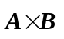is into the page (the – z-direction). The magnitude of the vector product is, from Eq. (1.22),

Or, using Eq. (1.27) and noting that the only non-vanishing component is

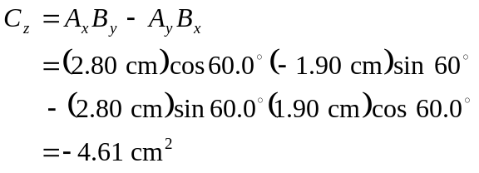

gives the same result.

- Rather than repeat the calculations, Eq. (1-23) may be used to see that 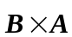 has magnitude 4.61 cm² and is in the +z-direction (out of the page).

